THE CHURCH
in
Mallory, New York
Est. 1833
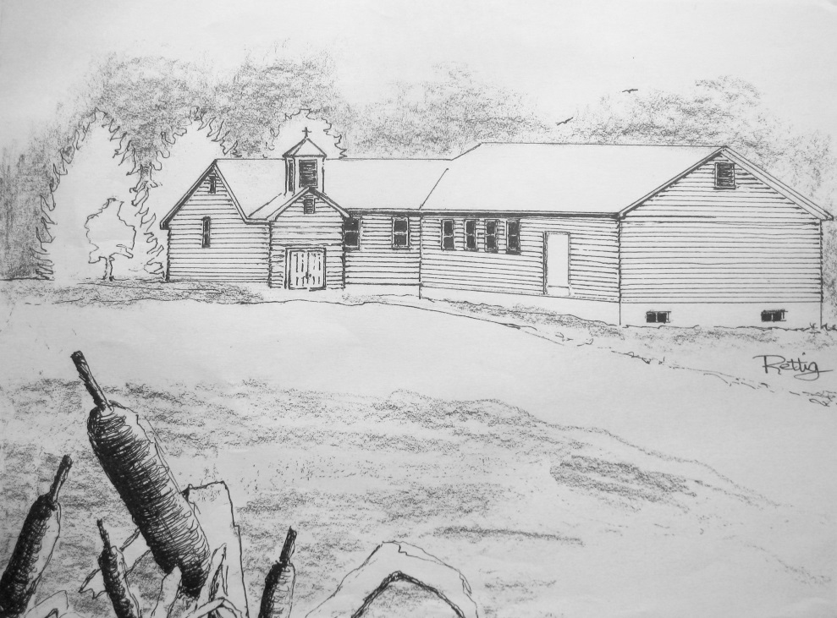
CELEBRATING 50 YEARS
…At this site…
1964 - 2014
“Making Friends Into Family”
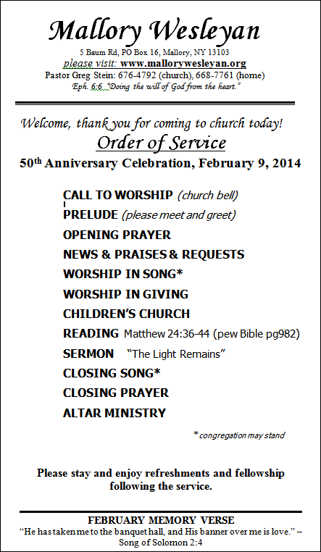
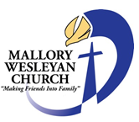
Mallory Wesleyan Church

PO Box 16, 5 Baum Road, Mallory, New York 13103
Pastor • Rev. Gregory Stein
Church: (315) 676-4792
www.mallorywesleyan.org

A note from the pastor;
God must be given all glory, honor, and praise for the establishment, existence, and success of His church. Every local church can trace its history and recognize key moments and special people that God has used to influenced its path. The Mallory church is no different. After 180 years in Mallory (celebrating 50 years at the current site) we need to acknowledge the Lord’s faithfulness in keeping His church in this small rural community.
Our history records some difficult times; times when the church doors all but closed. But, He had other plans. He called His servants (sometimes just one) to prayer and sacrifice and service and the Mallory church continued on. Methodist, Baptist, Independent, Wesleyan…the affiliations have changed but the Spirit of God remained the same. We owe a great debt of gratitude to God and to those He has chosen across almost two centuries to keep this work alive. The memorial prayer garden bricks displayed today remember only a few of those who have faithfully served here. There have been many, many more; some long forgotten by men but remembered by God.

Souls have been saved here. Hearts have been changed.
Thank you Lord!
~ Pastor Greg
Est. 1833
Brief History:
The church in Mallory has been a witness for Christ in the Central Square and Mallory area for over a century. Originally located in a small building in the center of Mallory, the congregation has changed its affiliation several times during its long history. About 1965, Pastor Ansel Gambrell led what was then Mallory Baptist Church from the building in the center of town to its present location on the hilltop at the western end of town. In 1986, Pastor A.J. Gibson invited several families who were moving into the area from Lyncourt Wesleyan Church to meet with the church on Sundays. The friendship led to the merge of the two congregations under a new name and denomination, Central Square Wesleyan Church. A large new sanctuary soon followed. In February, 2007 the church name was changed to Mallory Wesleyan to better reflect our location and the community we have served for so long.

A TIME LINE - GATHERED FROM DIFFERENT SOURCES - TO CREATE A PICTURE OF OUR PAST

1810 Our hamlet is called “Smith’s Mills”
Our hamlet changes its name to “Brewsterville”
1833 A Methodist class was organized in this area. In the early years of the Methodist class, the church was serviced by “Circuit Riders”. These “circuit riders” were pastors who traveled over a large region serving folks along the way. They met congregants on individual basis, sometimes gathering the community together in a home or community building and on rare occasion, in a church building.
1842 A revival was held
1851 A church was built and dedicated “Methodist Episcopal Society of Brewsterville” 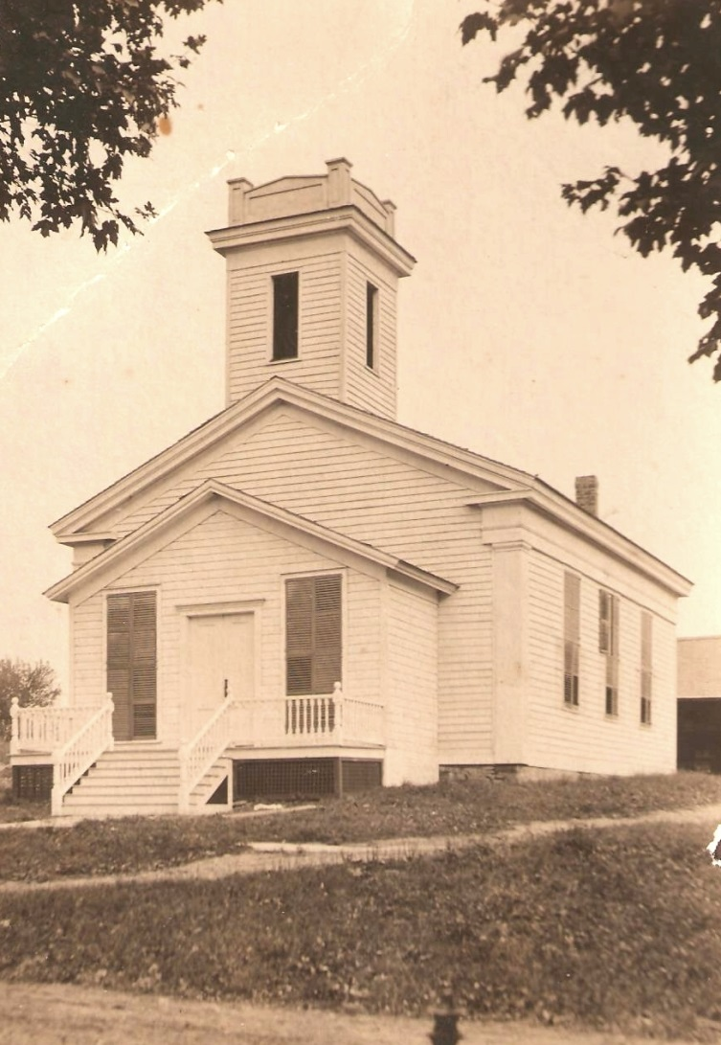
1850’s Our hamlet changes its name to “Mallory”
1930’s The Methodist church disbanded.
1960 (Winter) the Baptist church in Syracuse was contacted to start a church here in Mallory
1961 Jan 15: the Baptist assembly became a chapel known as “Mallory Baptist Chapel”.
March: Sunday school was started and afternoon services were held by Rev. Becker. The first service was in the old Methodist church building. The building was 113 years old in 1964. It still stands as a home in Mallory. (Red and white house about ½ way down County Route 32 toward County Route 37.
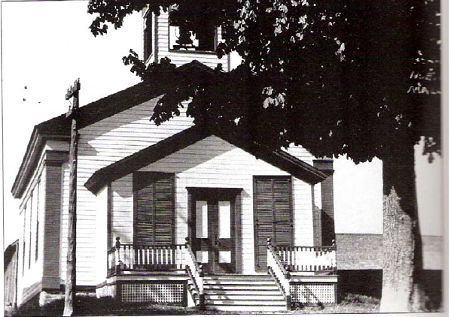
(When Rev Becker resigned his position from the First Southern Church of Syracuse, the laymen of that church continued services at this Baptist mission.)
June: VBS was held
July: Revival held by Rev. Tollison
1962 May: Revival, Visiting Pastor was Rev. Ansel K. Gambrell, Rehoboth Baptist Church
May 29, 1962: The church called Rev. Gambrell to service in Mallory.
July 8 – Aug 17: No pastor. Laymen from Syracuse church served along with Rev. Tollison, William Riley, layman preacher. Frank Scott, layman preacher, ordained in April 1962
1963 August 4: Ground Broken for New Baptist Chapel
August 5: Rev. Tollison started (wife Sara)
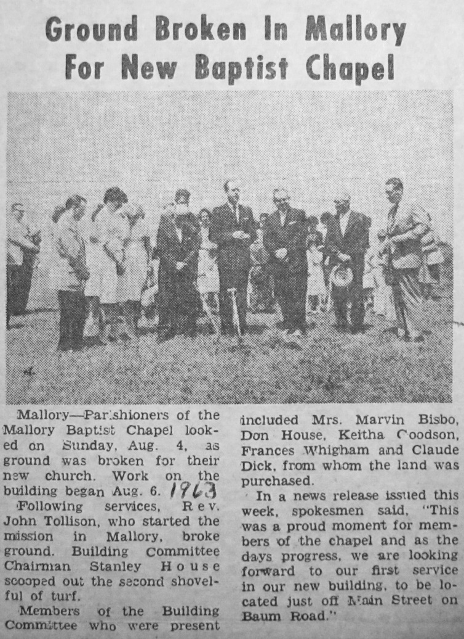
August 6: work began on the new building at 5 Baum Rd., Mallory.
1964 February 9, 1964 Dedication Service held for the new church building
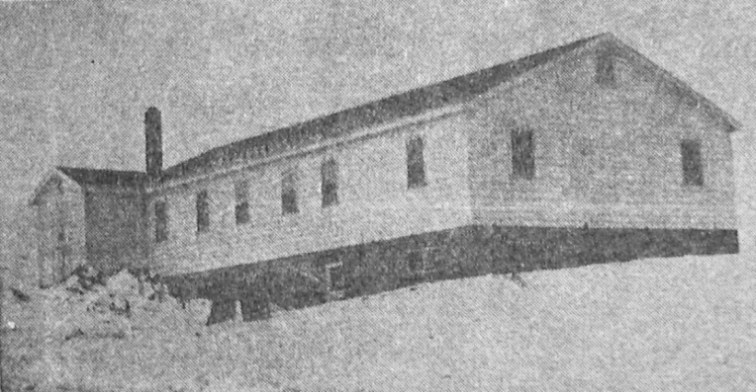
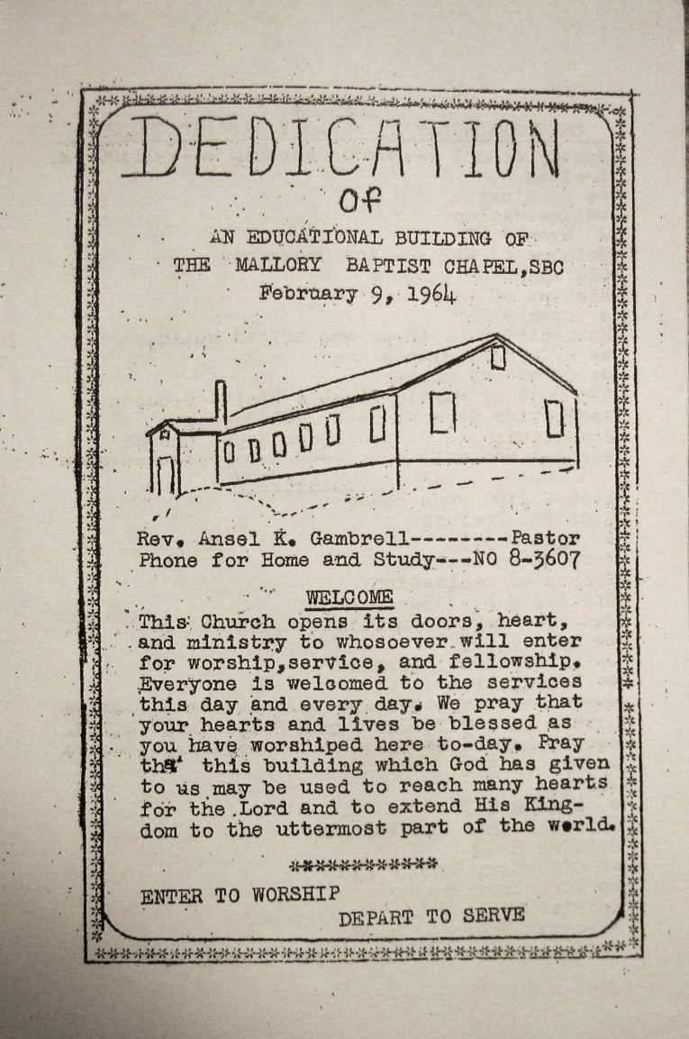
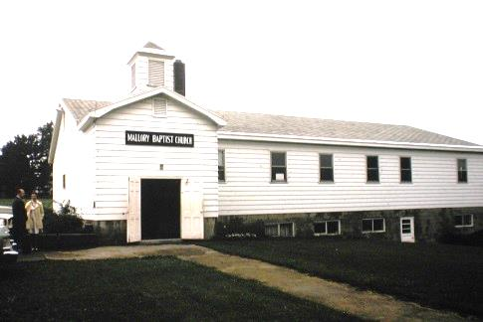
(1973 photo) Mallory Baptist
1988 Expansion of the Church Building
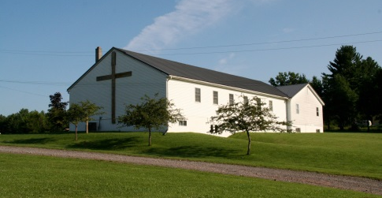
(2012 photo) Mallory Wesleyan
Pastors since 1964…

Aug 5, 1962-Sept 5, 1966
Ansel Gambrell (pronounced Gamble)

1967 - 1968 Austin Matthews

1968 – 1975 Erksin S. White
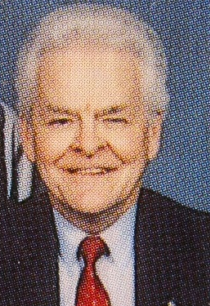

1976 - 1990
Pastor A. J. Gibson & Esther

1990 – 1995
Pastor Clair Day & Olive

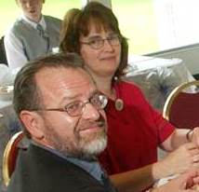

1995 – 2004
Pastor David Brown & Karen

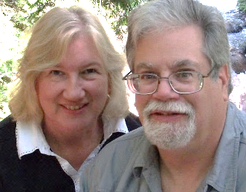

2004 – 2008
Pastor Timothy Hurne & Claudia

2008 - present
Pastor Gregory Stein & Marty

Pastors remembered
… but unsure when they served:
- Rev. Chester Winter
(prior to 1964)

- Rev. Anson Williams
(Methodist maybe from Penneville)

- Rev. Clark
- Rev. Hoyt
- Rev. Hodgen
Church Building Plaque
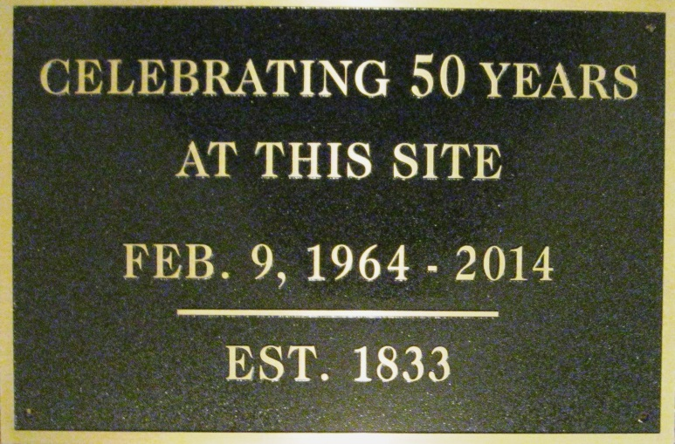

Prayer Garden Memorial Bricks
